**ANSWER 1:**

**CODE:**

using System;

namespace ConsoleApp1

{

class Program

{

static void Main(string[] args)

{

num obj1 = new num();

num obj2 = new num();

num obj3 = new num();

num obj4 = new num();

Console.WriteLine("Number of instances created " + num.count);

Console.ReadLine();

}

}

class num

{

public static int count = 0;

public num()

{

count++;

}

}

}**OUTPUT:**

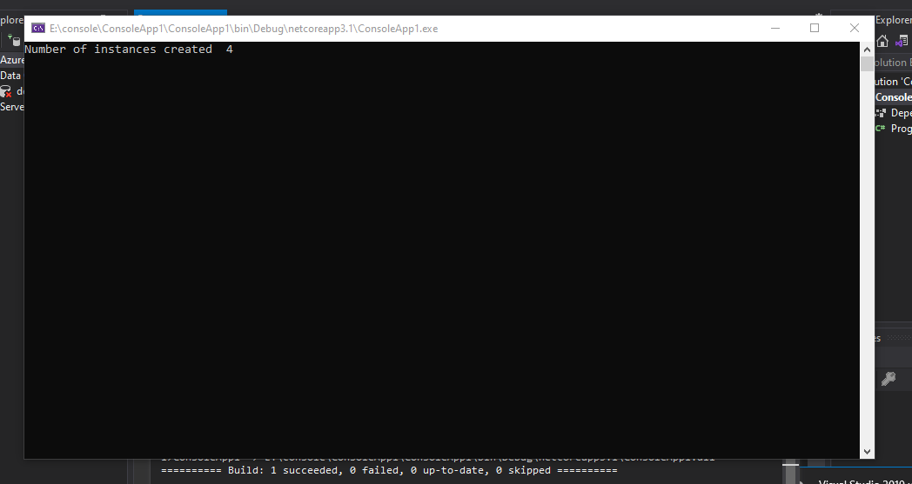

**ANSWER 2:**

**CODE:**

using System;

namespace ConsoleApp1

{

class client

{

public client()

{

server.count++;

}

}

public static class server

{

public static int count;

public static void show()

{

Console.WriteLine(count);

}

}

class Program

{

static void Main(string[] args)

{

client c1 = new client();

client c2 = new client();

client c3 = new client();

Console.Write("Total objects are =--------------> ");

server.show();

Console.ReadKey();

}

}

}

**OUTPUT:**

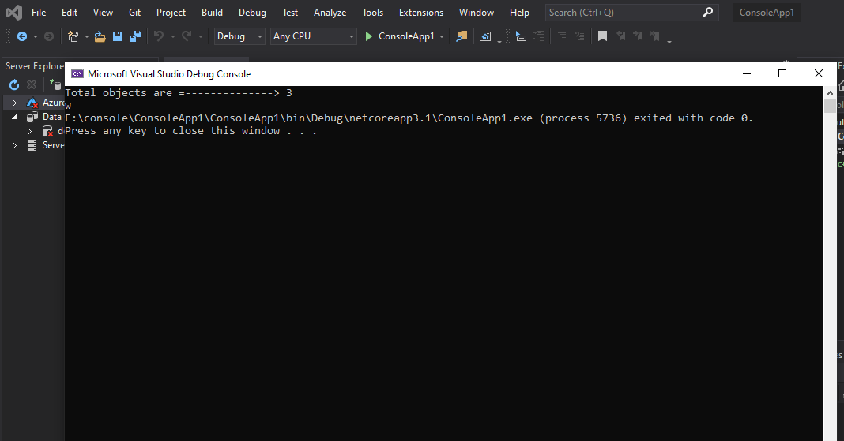

**ANSWER 3:**

**CODE:**

using System;

namespace ConsoleApp1

{

class client

{

static client()

{

server.show();

}

}

public static class server

{

public static void show()

{

Console.WriteLine("----------->client create <-----------");

}

}

class Program

{

static void Main(string[] args)

{

client c1 = new client();

client c2 = new client();

client c3 = new client();

client c4 = new client();

Console.ReadKey();

}

}

}

**OUTPUT:**

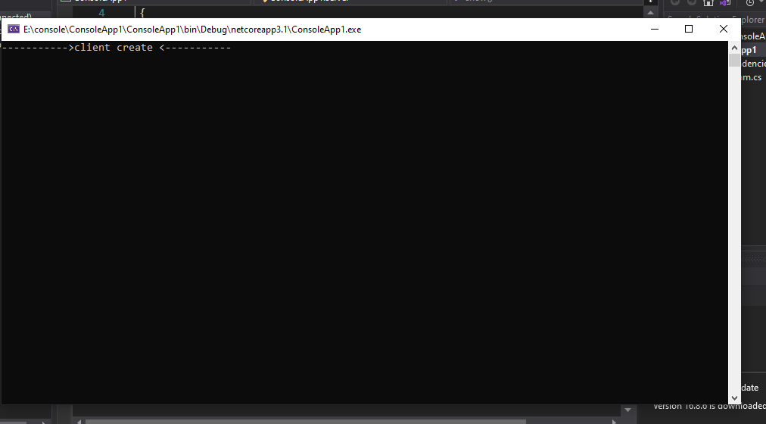

**Answer 4:**

**CODE:**

using System;

namespace ConsoleApp1

{

public class client

{

public client()

{

server.show();

}

}

public static class server

{

public static string name ;

public static string msg ;

public static string date;

public static void show()

{

Console.Write("Enter your name: ");

name = Console.ReadLine();

Console.Write("Enter your message: ");

msg = Console.ReadLine();

date = DateTime.Now.ToString();

Console.WriteLine("Message sent from "+name);

Console.WriteLine("Message= "+msg);

Console.WriteLine("Date of time this message "+date);

Console.WriteLine();

}

class Program

{

static void Main(string[] args)

{

client c1 = new client();

Console.ReadKey();

}

}

}

}

**OUTPUT:**

